ECA0302 – SIGNALS AND SYSTEMS
Ragavarshini R
192512027
CO1 – EXP 1- 6
- To generate and visualize basic continuous-time signals such as unit step, unit impulse, ramp, sinusoidal, and exponential signals
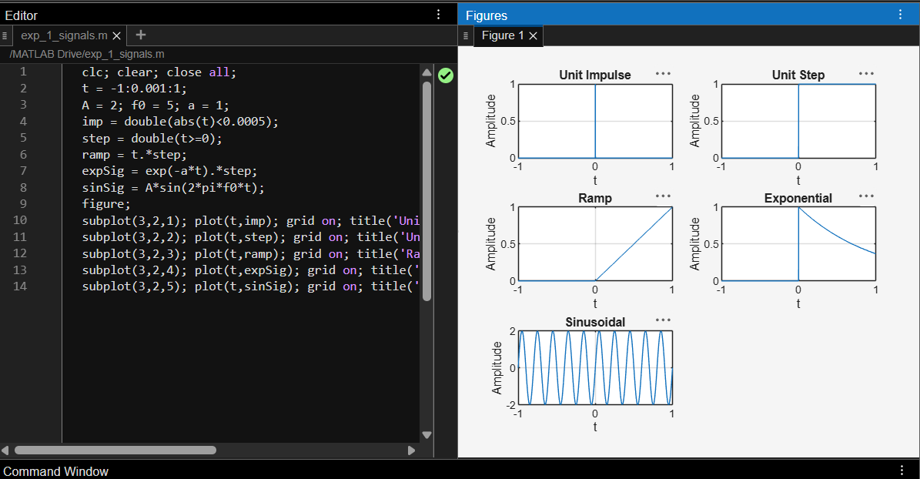
- To generate and visualize basic discrete-time signals and analyze their amplitude and time-index characteristics.
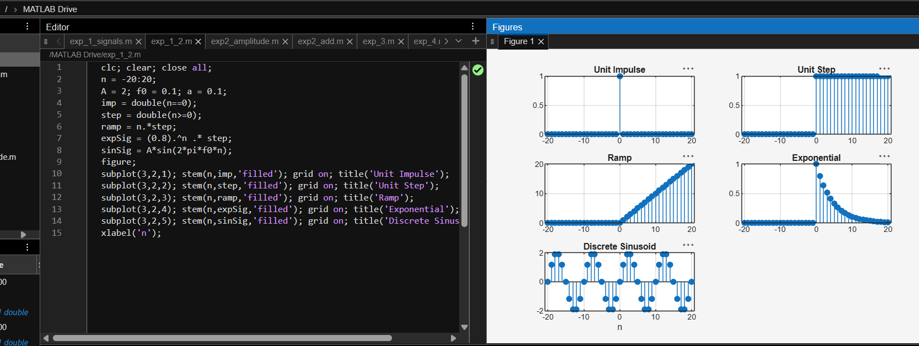

- To perform amplitude scaling and time scaling of continuous-time and discrete-time signals and analyze their effects on signal characteristics.
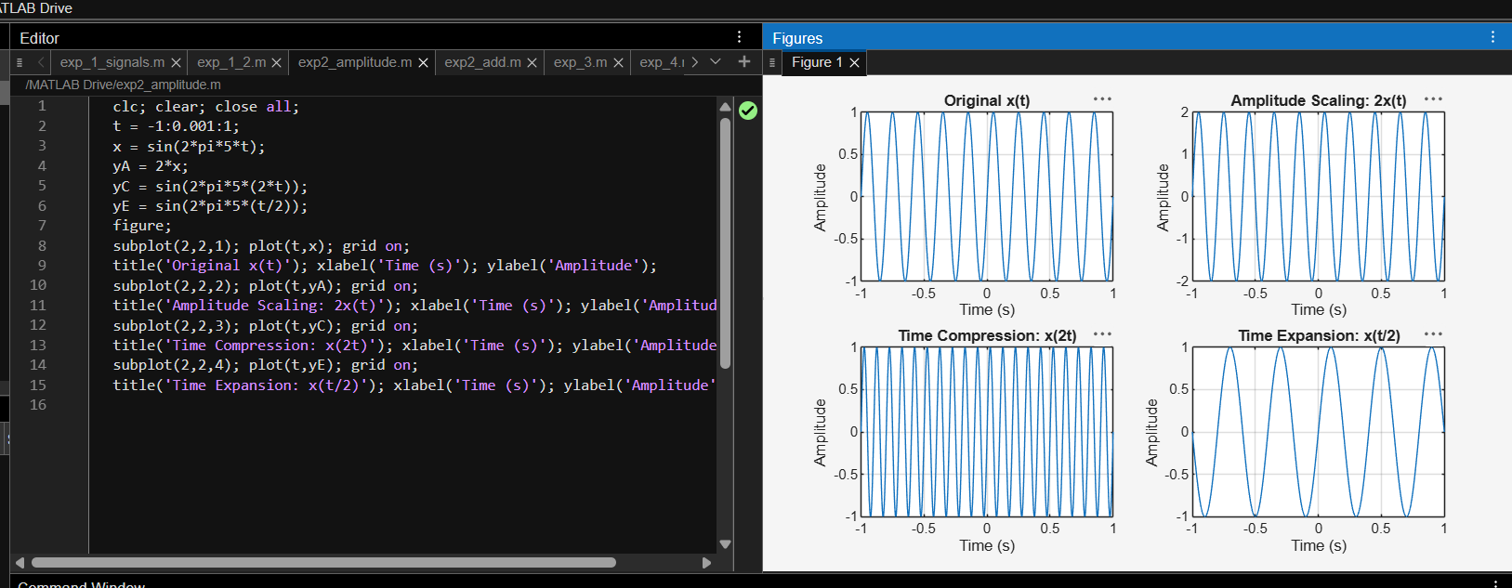
- To perform addition and multiplication of two discrete-time sequences and analyze the resulting signal characteristics
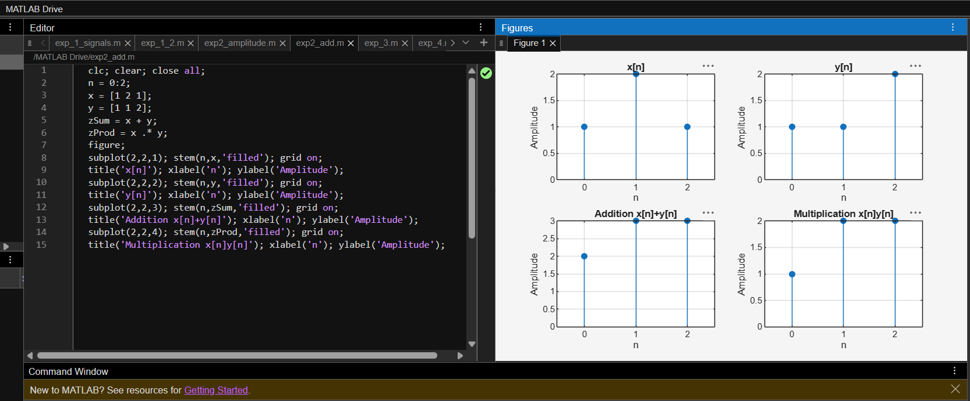

- To calculate the energy and average power of given continuous-time and discrete-time signals and classify them as energy signals, power signals, or neither based on their energy and power characteristics.
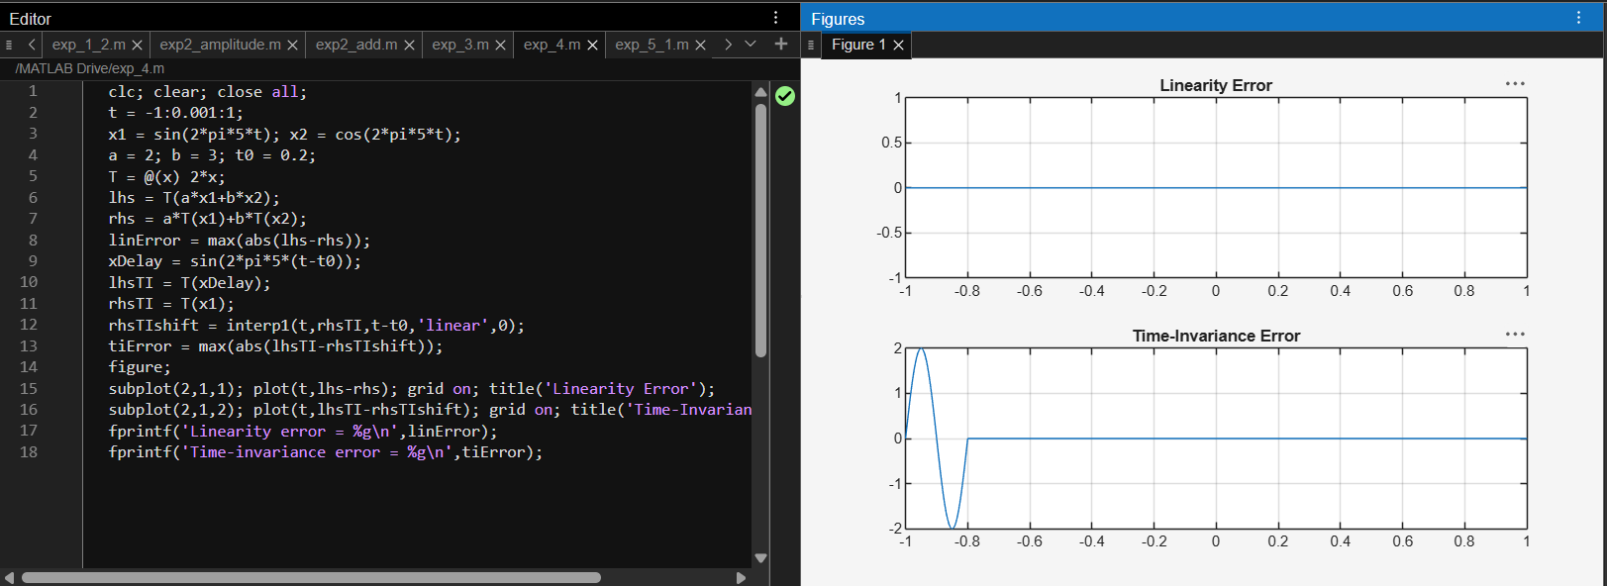
- To verify the linearity and time-invariance properties of continuous-time and discrete-time systems using suitable input signals and system responses.
